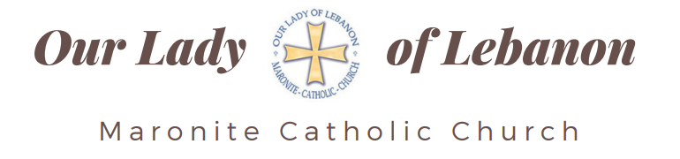

Parishioner Registration Form
For more information, visit www.ollchicago.org
or call 630-932-9640

Welcome to Our Parish Family
Welcome to Our Lady of Lebanon Maronite Catholic Church.
Please complete this form so we may better serve, accompany, and stay connected with you.
Date of Registration: ______________________
Envelope Number (Office Use): ______________________

Household Information
Primary Contact | Spouse
Full Name: __________________________ | Full Name: __________________________
Date of Birth: ______________________ | Date of Birth: ______________________
Cell Phone: _________________________ | Cell Phone: _________________________
Home Phone: ________________________ | Home Phone: ________________________
Email Address: ______________________ | Email Address: ______________________
Occupation: _________________________ | Occupation: _________________________

Home Address
Street Address: ________________________________________________
City: _______________________ State: __________ ZIP: ____________
Previous Parish (if applicable): ___________________________________

Sacramental Information
Primary Contact
Baptized Catholic? ☐ Yes ☐ No
Confirmed/Chrismated? ☐ Yes ☐ No
Married in the Catholic Church? ☐ Yes ☐ No
Parish/Church of Marriage (if applicable): ___________________________

Spouse
Baptized Catholic? ☐ Yes ☐ No
Confirmed/Chrismated? ☐ Yes ☐ No
Married in the Catholic Church? ☐ Yes ☐ No
Parish/Church of Marriage (if applicable): ___________________________
Children
Name | Birth Date | School Grade | Baptized | First Communion | Chrismation/  Confirmation | Sunday School
 |  |  | ☐ Yes  ☐ No | ☐ Yes ☐ No | ☐ Yes ☐ No | ☐ Yes  ☐ No
 |  |  | ☐ Yes  ☐ No | ☐ Yes ☐ No | ☐ Yes ☐ No | ☐ Yes  ☐ No
 |  |  | ☐ Yes  ☐ No | ☐ Yes ☐ No | ☐ Yes ☐ No | ☐ Yes  ☐ No
 |  |  | ☐ Yes  ☐ No | ☐ Yes ☐ No | ☐ Yes ☐ No | ☐ Yes  ☐ No
 |  |  | ☐ Yes  ☐ No | ☐ Yes ☐ No | ☐ Yes ☐ No | ☐ Yes  ☐ No

Parish Life & Ministries
Please let us know areas in which you are interested:
☐ Bible Study
☐ Choir
☐ MYA (Young Adults)
☐ MYO (Youth Organization)
☐ Sunday School / MRE
☐ Altar Servers
☐ Ushers / Hospitality
☐ Volunteer Opportunities
☐ Charity Outreach
☐ Women’s Group
☐ Men’s Group
☐ Visiting the Homebound
☐ Parish Events & Festivals
☐ Media / Technology
☐ Other: ___________________________________

Communication Preferences
I would like to receive parish communications through:
☐ Email
☐ Text Message / SMS
☐ WhatsApp
Cell Number for Texts/WhatsApp (if different): _______________________

Emergency Contact
Name: ______________________________________
Relationship: ________________________________
Phone Number: ______________________________

Pastoral Care
Would you like any of the following?
☐ House Blessing
☐ Pastoral Visit
☐ Meeting with the Pastor
☐ Communion for Homebound
☐ Hospital Visit
☐ Prayer Requests
Additional Information: ___________________________________________

Notes / Special Considerations
Please share any allergies, medical conditions, educational needs, or other important information that may help us better serve your family:

I certify that the information provided above is accurate to the best of my knowledge.
Signature: ______________________________________
Date: __________________________________________

Office Use Only
Entered into Database: ☐ Yes ☐ No
Entered By: ____________________________________
Follow-Up Contact Made: ☐ Yes ☐ No
Notes: _________________________________________

Please return this form to the parish office, drop in the collection basket, or mail to:
Our Lady of Lebanon
950 N. Grace Street
Lombard, Il 60148

Or email it to: office@ollchicago.org

